Diriyah Gate Development Authority
Design & Development Department

Pre-Qualification Questionnaire for Contractors
2020

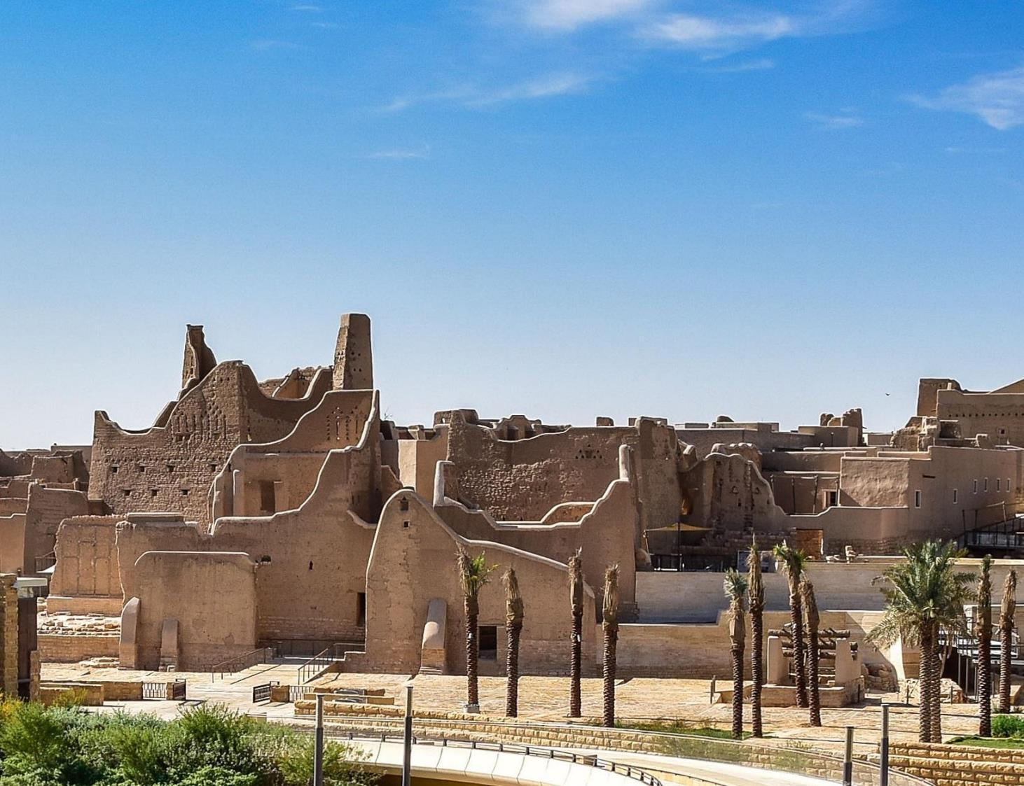
16يوليو 2018
829 KB

Part 1 - Introduction

As part of the Diriyah Gate Project (DG), Diriyah Gate Development Authority (DGDA) is taking the step to develop information guidance and soliciting information for evaluating and establishing contractor qualifications.

DGDA requires interested contractors to establish a proof of their proficiency and responsibility through submitting a prequalification questionnaire, together with any requested supplemental information for the purpose of evaluating contractors.

The questionnaire will be comprehensively reviewed and evaluated by DGDA, taking into consideration the following aspects:

- Relevant International and Local Experience.
- Quality and Performance.
- Financials and Resources,
- Health, Safety, and Environment performance,
- Client references.
- Fast track project delivery experience.

The above factors are the basis of rating and evaluating the contractors relative to the size /scope of the projects to which they will be qualified for.

The following would be considered grounds for disqualifying the applicant:
- Incomplete or false information
- Non-declaration of no conflict of interest
- Non-submission of declaration duly signed and stamped
- Failure to answer all questions
- Failure to submit the requested documentation

Instructions:

- All questions must be answered in English in the dedicated colored gray space. Write “NA” for questions that do not properly apply to your Company. This will not count against the contractor in any scoring process.

- All answers must be typed and should be as complete as possible to ensure fair grading.

- If additional space is required to answer any question, provide the answer on separate sheets at the end of this questionnaire. List any extra sheets in Section H. Where any supplementary information is provided, clearly cross reference the respective section number and heading.

- Data provided are to be clearly and wholly related to the Company seeking pre-qualification.

- If any data provided is for a subsidiary, J.V., parent, associate or other Company, you are to clearly state so in this form.

- If this Company is, or intends to form, a Joint Venture (J.V.), or Consortium or other association of companies, all J.V. or Consortium partners, etc., must submit separate pre-qualification forms in addition to the joint pre-qualification form submitted by the J.V. or Consortium.

- All pages must be stamped with the Company stamp.

- Prequalification must be renewed annually 30 days prior to the expiration date through submitting a renewal questionnaire. If a renewal questionnaire is not received, a regular prequalification questionnaire must be submitted again.

Return the completed form via email to ddtenders@dgda.gov.sa or electronic copy to be uploaded and submitted via link (i.e. WeTransfer)

(Part 2) Pre- Qualification Questionnaire
- General Information:

- Name of Company:

- Scope of works:

- Headquarters office address:

- Local KSA office address (if different from or in addition to 3):

- Name / Title of Primary Contact person:

- Address:

- E-mail:

- Telephone: Mobile: Fax:

- Name / Title of Secondary Contact person:

- Address:

- E-mail:

- Telephone: Mobile: Fax:

- Commercial Information:
- CR Number / Registration Number:

- Attach copy of Registration Certificate:

- Date of Registration: Expiration Date:

- Registration Type:

- Financial Information:

- Annual turnover of contracting works undertaken for each of the last four years and value of works projected for the current year:
Region | Current (2019) | 2018 | 2017 | 2016 | 2015
Saudi Arabia
Other Countries
Total

Provide a % estimate of the above values directly applicable to this scope of service
Region | Current (2019) | 2018 | 2017 | 2016 | 2015
Saudi Arabia
Other Countries
Total

- Provide the last five (5) years audited financial statement.

- Name and contact of director responsible for financial matters

- Provide evidence of your ability to submit professional indemnities and/or bank guarantees and/or parent company guarantees:
- Provide details of all current insurances (professional indemnity, public liability, third party insurance, contractors all risk etc) presently held by your Company along with their value and expiry date:
Insurance Type | Value | Expiry Date

- Indicate whether your Company has been or is the subject of any bankruptcy or insolvency proceeding or is subject to assignment for the benefits of creditors.

- Provide details of any pending law suits or claims in which you are directly involved.

- Has your Company failed to complete any appointment awarded to it? If so, why and when?

- Specify whether your Company ever had its employment terminated under the terms of an appointment for reasons other than the convenience of the client:

- Specify if there are any judgments/claims or suits pending or outstanding against your Company, or if there are any ongoing disputes (including formal legal proceedings or where the client has deducted or threatened to deduct money for poor performance). If yes, provide further details:

- Statement of no conflict of Interest. Does your Company have any association, directly or indirectly, with any member or employee of the client’s organization?

- Organization Structure and Qualifications:

- Organization type:

☐ Corporation
☐ Joint Venture
☐ Limited Liability Company
☐ Limited Collective Partnership
☐ Individual or Sole Proprietorship.
☐ Establishment
☐ Private Limited Company
☐ Partnership

☐ Others:

- Permanent Executives, partners, or owners Information: In case of JV provide names of all partners clearly defining the lead partner and the contractual relationship with other partners:

Name | Position | Years of Experience | Qualification

- If a member of a group of companies, give the name, address, and contact details of the Group or Ultimate Holding Company and any other subsidiaries that would guarantee the contract performance of its subsidiary:

- Attach a properly referenced organization chart showing your Company’s structure including all departments and other associated companies (parent company, subsidiaries, sister companies, JV, etc.) where applicable.

- List all staff, number and years of experience under your sponsorship.
Staff | Years of Experience |  |  |  | Total
 | 0-4 | 5-9 | 10-14 | 15+
Directors/Partners
Project Director/Manager
Others [contractor to add]
Total

- Number of Registered Professional Engineers with Saudi Council of Engineers:

- Provide information about company currently owned and leased equipment relevant to the scope of work:

Equipment Type | Number of Equipment (Owned) | Number of Equipment (Leased/Rented)

- Provide a brief description of the Company’s primary business, diversification, and main services inSaudi Arabia, the Middle East, and worldwide:
Item | Services | Description
Primary Business
Secondary Business
Other

- Indicate the name of any professional or industry associations of which your Company is a member and provide copies of relevant certification:

- List names, contact details, and length of time that you have been working with any associates your Company has in Saudi Arabia and overseas, who are versed and knowledgeable in the procedures of procurement, customs, importation, regulations, etc.:
Name | Address | Duration

- Contracting Experience and Capability:

- Description of Company's principal sector activities:

☐ Infrastructure.
☐ Temporary Buildings.
☐ Hospitality.
☐ Residential.
☐ Commercial
☐ Civic / Community Facilities
☐ Health
☐ Educational
☐ Recreational

☐ Mud/Adobe construction
☐ Retail / F&B / Mixed Use
☐ Landscaping.
☐ Cultural / Historic
☐ Public Transportation.
☐ Public Stations.
☐ Airports
☐ UNESCO Project Experience
☐ Master planning

☐ Other: If multiple sectors are identified above, please identify your particular area of expertise or interest

☐ Other: If your company is on the KSA government approved lists, please identify ranking and under which category

- Number of years of experience as a Contractor:
Work Zone | Experience in Years
Experience in Riyadh
Experience in Saudi Arabia
Experience in Middle East (Include GCC)

- Mark the percentage of work that your Company usually self performs as a principal contractor self-performing the works and/or subcontracted:
- Self-performed: ☐ (10% - 30%) ☐ (30% - 60%) ☐ (60% - 100%)
- Subcontracted: ☐ (10% - 30%) ☐ (30% - 60%) ☐ (60% - 100%)

- If it is foreseen that any part of a contract will be sub-contracted, state the type of work likely to be undertaken by sub-contractor(s) and, if known, give the names and addresses of major sub-contractor(s).

Scope of Service | Sub-Contractor | Address and Contact Info

- List the largest/landmark single contracts the Company has completed within the past 5 years:

2015
Project Name
Worked as | ☐ Principal Contractor | ☐ Sub - Contractor
Type of Work
Project Value
2016
Project Name
Worked as | ☐ Principal Contractor | ☐ Sub - Contractor
Type of Work
Project Value

2017
Project Name
Worked as | ☐ Principal Contractor | ☐ Sub - Contractor
Type of Work
Project Value
2018
Project Name
Worked as | ☐ Principal Contractor | ☐ Sub - Contractor
Type of Work
Project Value
2019
Project Name
Worked as | ☐ Principal Contractor | ☐ Sub - Contractor
Type of Work
Project Value

- List the largest/landmark single contracts the Company has completed within Saudi Arabia in the past 5 years:

2015
Project Name
Worked as | ☐ Principal Contractor | ☐ Sub - Contractor
Type of Work
Project Value
2016
Project Name
Worked as | ☐ Principal Contractor | ☐ Sub - Contractor
Type of Work
Project Value

2017
Project Name
Worked as | ☐ Principal Contractor | ☐ Sub - Contractor
Type of Work
Project Value

2018
Project Name
Worked as | ☐ Principal Contractor | ☐ Sub - Contractor
Type of Work
Project Value
2019
Project Name
Worked as | ☐ Principal Contractor | ☐ Sub - Contractor
Type of Work
Project Value

- Use the following table to list previous contracts within last 5 years (from highest to lowest):

Project Name and Location | Description | Award Date | Completion Date | Value in SAR | Completion % | Client Contact

- Capacity: List major current ongoing projects names, location and respective values (from highest to lowest):

Project Name | Award Date | Location | Total Value | % Complete

- Identify capacity and approach to resourcing to undertake fast track work within the next 12 months covering the following points (separate document/file may be attached):
- What is your approach to fast track project delivery and forms of contract?
- What is your experience of the above, in performing previous fast track projects?
- What are the critical requirements to meeting fast track programmes?
- Experience with securing supply chain to design packages release procurements.
- How and from where will the project be resourced?
- How will you ensure that you fully understand and implement local codes and regulations?
- How is safety controlled and assured in fast track works execution?
- How is quality maintained and assured in fast track works execution?

- Quality / HSE / LEED / IT

- Indicate if your Company operates a Quality Management System that complies with the following and provide certification where externally accredited:

QMS System | Yes | No | Date Accredited | Seeking
BSEN/ISO 9000
BSEN/ISO 9001
BSEN/ISO 9002
In-house Quality System
Other (Specify)

- Provide details of your Company’s environmental policy:

- Provide brief details of key projects which your Company has completed/or under construction, which have achieved or are targeting a LEED (or equivalent) rating:

Project Name | Rating | Description

- Provide a statement of your HSE record on projects in which your Company has been appointed on in the past five years:

- IT systems: Describe your Company’s experience with document management/collaboration systems (eg: Aconex)

- BIM: Can you undertake your engineering using BIM system of 3D modelling? If so, provide screenshots showing integrated models of previous projects undertaken.

- Additional Information:
If you need to provide extra pages to complete this questionnaire or wish to provide additional information that you consider relevant to the evaluation of your qualifications, please list below all the enclosures that are provided as attachments. Where any supplementary information is provided, clearly cross reference the respective section number and heading.

- Client References

Provide below details for 3 relevant client references:

Reference 1
Project Name
Project Value
Owner / Organization Name
Contact Person
Address
Contact Number

References 2
Project Name
Project Value
Owner / Organization Name
Contact Person
Address
Contact Number

Reference 3
Project Name
Project Value
Owner / Organization Name
Contact Person
Address
Contact Number

- Attachments:

Provide the following attachments (where applicable) together with the questionnaire:

  - Company Profile
  - Commercial Registration / Investment License
  - GOSI Certificate
  - Saudization Certificate
  - Valid Zakat and V.A.T. Certificates
  - SAGIA Certificate (if applicable)
  - Chamber of Commerce Registration
  - Company’s HSE Manual
  - Health Safety Management System
  - ISO Certificates (where applicable)
  - Company’s QMS certificates

End of Questionnaire

Declaration

We declare and confirm that we hereby understand that the DGDA is relying upon the information provided by ourselves to assess whether our Company is suitable to be included as a supplier to DGDA.

We furthermore understand that DGDA’s assessment is dependent upon the accuracy of the details and information provided by us.

Accordingly, we hereby declare and confirm that:
- The details and information provided by us for the Client’s assessment are true and accurate and are known to us as facts.
- We do not knowingly or recklessly give false, inaccurate or misleading details or information.
- Should we provide any false or misleading information, it will result in our application being rejected and our Company being black-listed.

Duly authorized to sign this Declaration for and on behalf of the Construction Company (must be typewritten)

Signature (must be original, wet signature)

Date:

Registration Stamp (must be wet stamp, no electronic images)

